**BANK LOAN REPORT QUERIES**

**BANK LOAN REPORT | SUMMARY**

KPI’s:

**Total Loan Applications**

SELECT COUNT(id) AS Total_Loan_Application FROM Bank_loan_data

**MTD Loan application**

SELECT COUNT(id) AS MTD_Total_Application FROM Bank_loan_data

WHERE MONTH(issue_date) = 12 AND YEAR(issue_date) = 2021



**PMTD Loan application**

SELECT COUNT(id) AS PMTD_Total_Application FROM Bank_loan_data

WHERE MONTH(issue_date) = 11 AND YEAR(issue_date) = 2021



**Total Funded Amount**

SELECT SUM(loan_amount) AS Total_Funded_Amount FROM Bank_loan_data



**MTD Total Funded Amount**

SELECT SUM(loan_amount) AS MTD_Total_Funded_Amount FROM Bank_loan_data

WHERE MONTH(issue_date) = 12 AND YEAR(issue_date) = 2021



**PMTD Total Funded Amount**

SELECT SUM(loan_amount) AS PMTD_Total_Funded_Amount FROM Bank_loan_data

WHERE MONTH(issue_date) = 11 AND YEAR(issue_date) = 2021



**Total Amount Received**

SELECT SUM(total_payment) AS Total_Amount_Received FROM Bank_loan_data



**MTD Total Amount Received**

SELECT SUM(total_payment) AS MTD_Total_Amount_Received FROM Bank_loan_data

WHERE MONTH(issue_date) = 12 AND YEAR(issue_date) = 2021



**PMTD Total Amount Received**

SELECT SUM(total_payment) AS PMTD_Total_Amount_Received FROM Bank_loan_data

WHERE MONTH(issue_date) = 11 AND YEAR(issue_date) = 2021



**Average Interest Rate**

SELECT AVG(int_rate) * 100 AS Avg_Interest_Rate FROM Bank_loan_data



**MTD Average Interest Rate**

SELECT AVG(int_rate) * 100 AS MTD_Avg_Interest_Rate FROM Bank_loan_data

WHERE MONTH(issue_date) = 12 AND YEAR(issue_date) = 2021



**PMTD Average Interest Rate**

SELECT AVG(int_rate) * 100 AS PMTD_Avg_Interest_Rate FROM Bank_loan_data

WHERE MONTH(issue_date) = 11 AND YEAR(issue_date) = 2021



**Avg DTI**

SELECT AVG(dti) * 100 AS Avg_DTI FROM Bank_loan_data



**MTD Avg DTI**

SELECT AVG(dti) * 100 AS MTD_Avg_DTI FROM Bank_loan_data

WHERE MONTH(issue_date) = 12 AND YEAR(issue_date) = 2021



**PMTD Avg DTI**

SELECT AVG(dti) * 100 AS PMTD_Avg_DTI FROM Bank_loan_data

WHERE MONTH(issue_date) = 11 AND YEAR(issue_date) = 2021



**GOOD LOAN**

**Good loan Percentages**

SELECT (COUNT(CASE WHEN loan_status = 'Fully Paid' OR loan_status = 'Current' THEN id END) * 100.0)/

COUNT(id) AS Good_loan_Percentages

FROM Bank_loan_data



**Good loan Applications**

SELECT COUNT(id) AS Good_loan_Applications FROM Bank_loan_data

WHERE loan_status = 'Fully Paid' OR loan_status = 'Current'



**Good Loan Funded Amount**

SELECT SUM(loan_amount) AS Good_loan_Funded_Amount FROM Bank_loan_data

WHERE loan_status = 'Fully Paid' OR loan_status = 'Current'



**Good Loan Total Received Amount**

SELECT SUM(total_payment) AS Good_loan_Received_Amount FROM Bank_loan_data

WHERE loan_status = 'Fully Paid' OR loan_status = 'Current'



**Bad Loan**

**Bad loan Percentage**

SELECT (COUNT(CASE WHEN loan_status = 'Charged off' THEN id END)*100.0)/

COUNT(id) AS Bad_loan_Percentage

FROM Bank_loan_data



**Bad Loan Applications**

SELECT COUNT(id) AS Bad_Loan_Applications FROM Bank_loan_data

WHERE loan_status = 'Charged off'



**Bad Loan Funded Amount**

SELECT SUM(loan_amount) AS Bad_Loan_Funded_Amount FROM Bank_loan_data

WHERE loan_status = 'Charged off'



**Bad Loan Total Received Amount**

SELECT SUM(total_payment) AS Bad_Loan_Received_Amount FROM Bank_loan_data

WHERE loan_status = 'Charged off'



**LOAN STATUS**

SELECT

loan_status,

COUNT(id) AS Loan_Applications,

SUM(loan_amount) AS Total_Funded_Amount,

SUM(total_payment) AS Total_received_Amount,

AVG(int_rate)* 100 AS Interest_rate,

AVG(dti)* 100 AS DTI

FROM

Bank_loan_data

GROUP BY

loan_status

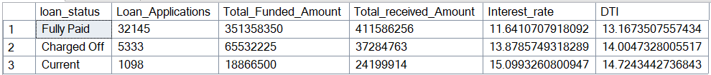

**MTD Loan Status**

SELECT

loan_status,

SUM(loan_amount) AS MTD_Total_Funded_Amount,

SUM(total_payment) AS MTD_Total_received_Amount

FROM

Bank_loan_data

WHERE

MONTH(issue_date) = 12 AND YEAR(issue_date) = 2021

GROUP BY

loan_status

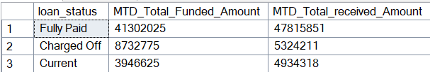

**PMTD Loan Status**

SELECT

loan_status,

SUM(loan_amount) AS MTD_Total_Funded_Amount,

SUM(total_payment) AS MTD_Total_received_Amount

FROM

Bank_loan_data

WHERE

MONTH(issue_date) = 11 AND YEAR(issue_date) = 2021

GROUP BY

loan_status

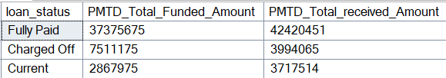

**BANK LOAN REPORT | OVERVIEW**

**Month**

SELECT

MONTH(issue_date) AS Month_Number,

DATENAME(MONTH,issue_date) AS Month_name,

COUNT(id) AS Total_Loan_Applications,

SUM(loan_amount) AS Total_Funded_Amount,

SUM(total_payment) AS Total_Received_amount

FROM

Bank_loan_data

GROUP BY MONTH(issue_date), DATENAME(MONTH,issue_date)

ORDER BY MONTH(issue_date)

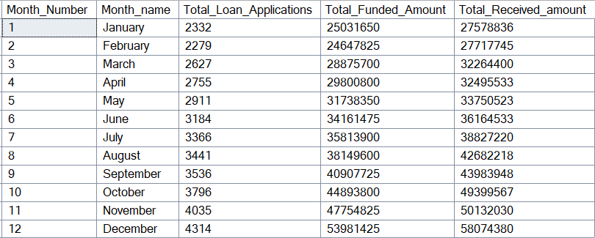

**State**

SELECT

address_state,

COUNT(id) AS Total_Loan_Applications,

SUM(loan_amount) AS Total_Funded_Amount,

SUM(total_payment) AS Total_Received_amount

FROM

Bank_loan_data

GROUP BY address_state

ORDER BY COUNT(id) DESC

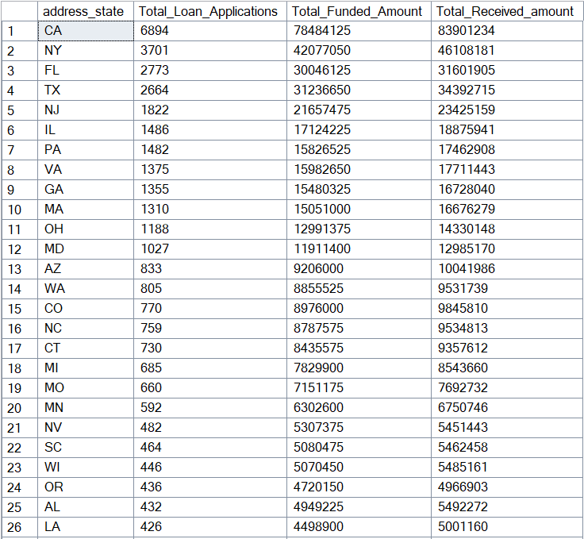

**TERM**

SELECT

term,

COUNT(id) AS Total_Loan_Applications,

SUM(loan_amount) AS Total_Funded_Amount,

SUM(total_payment) AS Total_Received_amount

FROM

Bank_loan_data

GROUP BY term

ORDER BY term

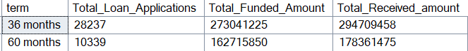

**EMPLOYEE LENGTH**

SELECT

emp_length,

COUNT(id) AS Total_Loan_Applications,

SUM(loan_amount) AS Total_Funded_Amount,

SUM(total_payment) AS Total_Received_amount

FROM

Bank_loan_data

GROUP BY emp_length

ORDER BY emp_length 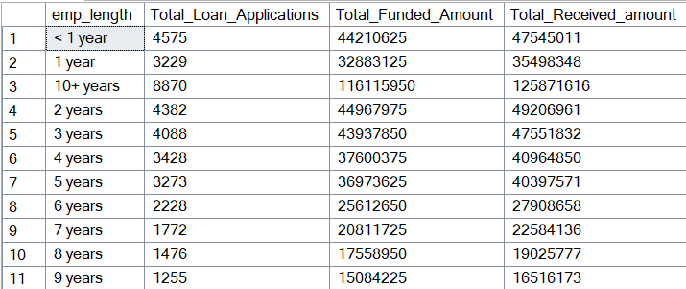

**PURPOSE**

SELECT

purpose,

COUNT(id) AS Total_Loan_Applications,

SUM(loan_amount) AS Total_Funded_Amount,

SUM(total_payment) AS Total_Received_amount

FROM

Bank_loan_data

GROUP BY purpose

ORDER BY COUNT(id) DESC

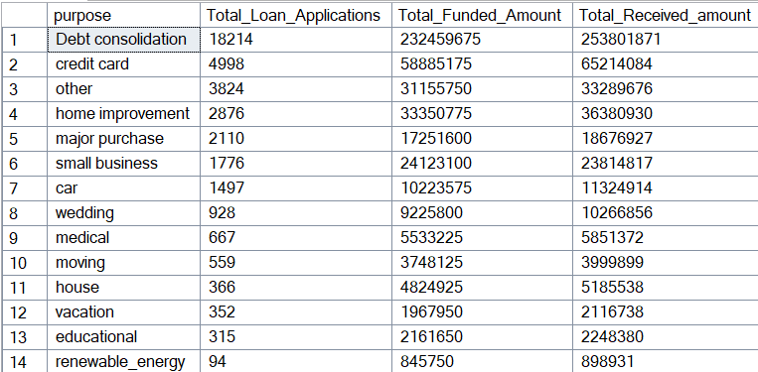

**HOME OWNERSHIP**

SELECT

home_ownership,

COUNT(id) AS Total_Loan_Applications,

SUM(loan_amount) AS Total_Funded_Amount,

SUM(total_payment) AS Total_Received_amount

FROM

Bank_loan_data

GROUP BY home_ownership

ORDER BY COUNT(id) DESC

